Nostra Backend (NodeJS) Developers Assignment

Nostra Movie Apps contain 2 screen :

1. List movie with category with searching feature
2. Detail Screen

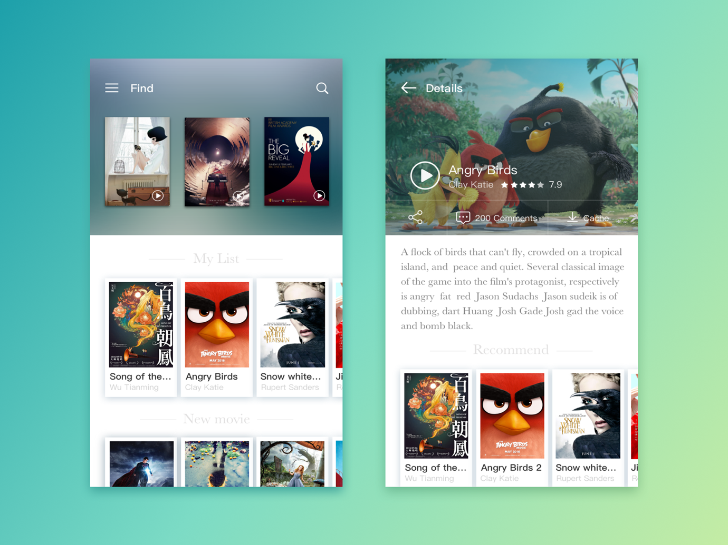

Create API **CRUD** for that 2 screen.

Requirements

* Your app should build use Spring Boot 2.x and Java 8 or higher
* Database Use Hibernate JPA with PostgreSQL or MongoDB with this configuration :
  + DB Name : Nostra Movie
  + Username : Nostra
  + Password : Nostra
* Your apps should have relational database
* Your app should handle rollback transaction
* Your apps should handle data stream
* Your apps must have [swagger](https://swagger.io/) for list API, structured API, sample request & response and detailed description for each API
* Add ReadMe.txt with detail :
  + List Requirement ( Java version, DB used etc )
  + How To Run Apps
  + Explanation List API for each screen
* Local git history. The easiest way for us to know that you’re capable work as a team.

Optional but Nice to haves

We use these things because you will learn them eventually when working with us.

* Integration to Amazon S3 or any media server for image or video
* Reactive API

Submitting your assignment

Once you’re done, zip your project **along with the .git folder** and mail it to our HR contact. Please **do not upload** your assignment to GitHub, Bitbucket, etc. **Only send it to us.**

You can always reach out to your HR contact if you have any doubts and they will ensure that someone from engineering team gets back to you.